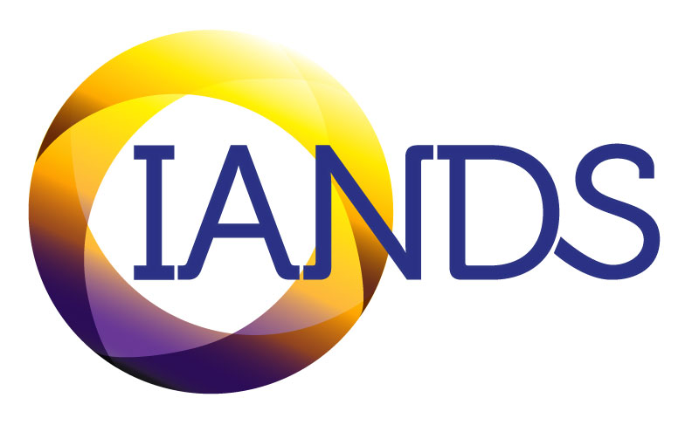
International Association for Near-Death Studies, Inc.

Instructions for researchers seeking IANDS support or collaboration
IANDS's policy is to support well-designed research studies. The primary way we have supported past researchers has been to distribute a request for people in our approximately 60 Friends of IANDS groups, located mostly across the US but some internationally, to answer on-line surveys. Another way has been to give qualified researchers access to the IANDS database of near-death experience accounts—the IANDS Experience Registry. If you would like to request support from IANDS, please take up to two pages to complete the following form, and return it, along with any attachments, to research_director@iands.org:
1. Synopsis of Study. Please describe the purpose and methodology of your study.

2. Describe how you would like IANDS to help you. If you are requesting access to IANDS’s Experience Registry, or specific information from the Registry, please complete the form on page 2 below.

3. Please attach a copy of your survey(s).
4. If your study has been approved by an Institutional Review Board (IRB), please attach a copy of the approval letter. If your study has not been IRB-approved, this application is subject to Academic and Research Committee approval.
5. If you would like IANDS to recruit participants via our approximately 60 US and/or international local groups, please provide the following:
- Place an “x” in the relevant blank(s): ___ US local groups. ___ International local groups
- Provide an email for IANDS to send to the relevant group leaders. See example on p. 3 below.
- Provide an email for IANDS and group leaders to send to their email lists. See example on p. 3 below.
6. Beginning date of the study:
7. Ending date of the study (at which time all reference to the study will be removed from the website):

Updated: March, 2024
EXPERIENCE REGISTRY ACCESS AGREEMENT
THIS AGREEMENT is entered into to be effective on the last date set forth below with signatures, between The International Association for Near-Death Studies (hereafter “IANDS”), a 501(c)(3) corporation, with headquarters in North Carolina, and ____________________________________________________________________________
(hereafter individually or jointly “Author”) for the consideration deemed sufficient by the parties.
1. IANDS receives accounts, narratives, stories, recordings, descriptions, manuscripts, data, and other kinds of information related to near-death experiences (hereafter “Narratives”) and stores them in the Experience Registry data base (hereafter the “Registry”).
2. IANDS makes the Narratives available to authors, researchers, and others, so long as they appropriately promote the interests and 501(c)(3) purposes of IANDS, as determined in the sole discretion of IANDS.
3. Author will submit to IANDS a written description of Author’s “proposed use” of Author’s access to the Registry and/or Narratives in the Registry.
4. To enable IANDS to determine whether access should be given, Author provides IANDS with a written description of all proposed uses. The written description is attached or provided by Author with this agreement, and includes Author’s background information, detailed description of proposed publication(s), planned use of Narratives and excerpts of Narratives, and all other information Author believes to be relevant.
5. Author agrees to abide by permissions specified in each registry submission, in particular (a) restrictions on publication of narratives, and (b) limits of contact between author and experiencer (no contact, or if contacted, experiencer’s right to accept or decline participation); and to maintain the confidentiality of experiencers’ personal and contact information.
6. Author must obtain IANDS’s written approval prior to any and all publication and/or media and any other final use. This means Author agrees to provide IANDS with a draft of any final proposed publication.
7. This agreement will be governed by the laws of the State of North Carolina without reference to the conflict of law principles.
8. This is the entire agreement and understanding of the parties hereto with respect to the subject matter contained herein and supersedes all prior agreements and understandings between the parties, written and oral, with respect to such subject matter.
9. This agreement may be amended and modified only by written agreement of the parties hereto. This agreement will not be assignable by any party.
10. This agreement is binding upon and inure to the benefit of the parties hereto and their respective successors and permitted assigns.
Understood and agreed to by Author and IANDS, executed by Author and IANDS authorized representative.
AUTHOR(S): DATED: ______________________
Author Signature _____________________________ Author typed name __________________________________
Author Signature _____________________________ Author typed name __________________________________
Author Signature _____________________________ Author typed name __________________________________
IANDS: DATED: ____________________
IANDS Representative Signature __________________ IANDS Representative Title __________________________
IANDS Representative typed name _______________________________________
Sample emails:

TO IANDS LOCAL GROUP LEADER:

Dear IANDS Local Group Leader:

My research team at the University of North Texas is conducting a study on the subjective experience of after-death communication (ADC): a feeling or sense of encountering someone physically deceased with whom one had a personal relationship. If you would be so kind, please forward the below message to the people on your local group email list. Thank you SO MUCH for your help!

Janice Miner Holden, EdD
Professor, Counseling Program
Chair, Department of Counseling & Higher Education
University of North Texas
Phone: (940) 565-2919
Email: Jan.Holden@unt.edu

TO IANDS LOCAL GROUP MEMBER AND/OR PERSON ON IANDS’S AT-LARGE EMAIL LIST (IANDS MEMBERS AND FRIENDS):

Dear IANDS Local Group Member, IANDS Member, or IANDS Friend,

Have you experienced after-death communication (ADC): a feeling or sense of encountering someone physically deceased with whom you had a personal relationship? NDErs often report having had this experience before, during, and/or after their NDEs, and many non-NDErs also have had this experience. If you have, please consider taking part in a University of North Texas study by completing an online survey examining people’s experiences of ADC. The survey should take no more than 30 minutes of your time, may provide you with a meaningful and reflective experience, and will further our understanding of the subjective experience and impact of ADC. To proceed, click on this link:

https://pretend.survey.hyperlink.com/abc_xyz
Thank you for your consideration!

Jan

Janice Miner Holden, EdD
Professor, Counseling Program
Chair, Department of Counseling & Higher Education
University of North Texas
Phone: (940) 565-2919
Email: jan.holden@unt.edu

